

Build a Healthy Meal

- Make Half Your Plate Fruits and Vegetables.

- Make at least Half your Grains Whole Grains.
Look for 100% whole grain or 100% whole wheat on labels.

- Choose a Lean Protein.
Try to have seafood twice a week.

- Choose Low-fat or Fat-free Dairy

- Avoid extra fat.
Don’t cover veggies with butter or cheese.

- Choose the right size portion for you. Your hand is the BEST measuring tool.

  - Two handfuls of veggies,
  - A fist of rice
  - A palm of protein
  - A fist of fruits
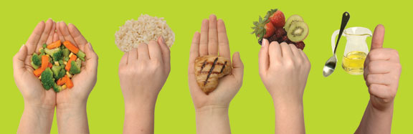
  - A thumb of fat

