I M P L E M E N T I N G H E A L T H Y L I V I N G I N O U R C O M M U N I T Y
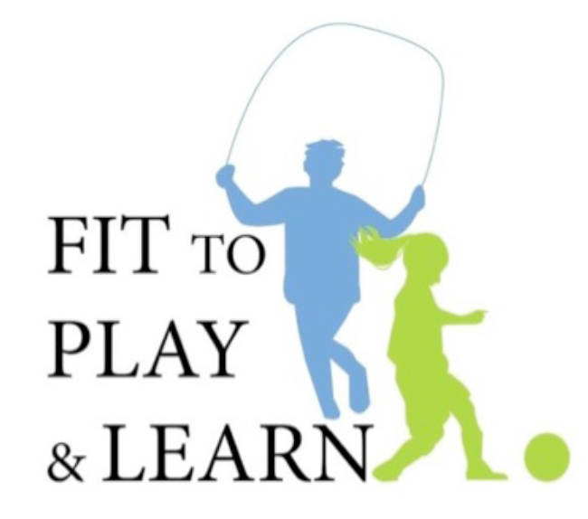
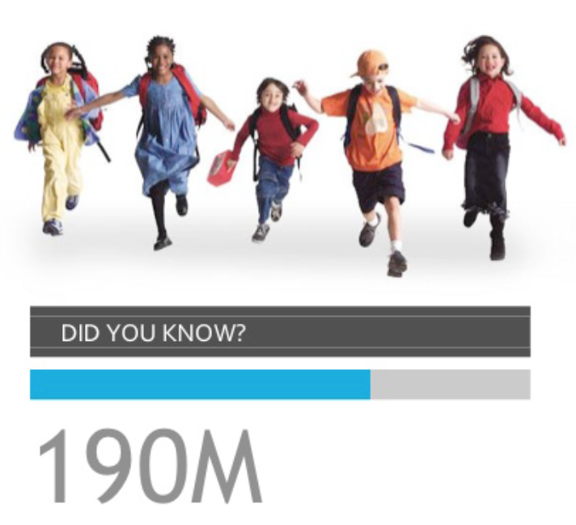

Americans are overweight or obese

1 in 3
Children are overweight
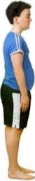
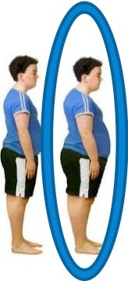

Fit to Play and Learn is an obesity prevention program for elementary and middle school students and their parents. The Fit to Play and Learn program was developed by two pediatricians, Drs. Cori Cross and Tracy Zaslow, with the goal of teaching kids to eat right and enjoy an active lifestyle. Drs. Zaslow and Cross have teamed up with the American Academy of Pediatrics California Chapter 2 (AAP-CA2) and the Los Angeles Unified School District (LAUSD) School Nurses Act to Prevent Obesity (SNAPO) to deliver this curriculum to students and their parents. The program’s curriculum is centered on encouraging healthy lifestyle choices for children at an early age. By incorporating education for parents, Fit to Play and Learn allows for dual-learning experiences for families concerning obesity prevention techniques.

Fit to Play and Learn has four main objectives:

    - Train school nurses to provide obesity prevention guidance to students and faculty

    - Educate students on healthy drink and food choices

    - Educate parents on healthy drink and food choices for themselves and their children

    - Provide teachers, students and parents tools to increase physical activity

In separate education sessions, the program integrates a hands-on learning approach, with physical activity exercises, food demonstrations, and other forms of student/parent participation.

3 KEY Fit to Play & Learn LESSONS
How to eat healthier "You Are W h at You Eat!"

Why water is t he best d rink choice "Get Sugar Smart"

Fun physical activities "Get Moving!"

CONTACT INFORMATION

If you have any questions or would like to contact the Fit to Play & Learn Team, please email us at fittoplayandlearn@gmail.com or visit us on the web at www.fittoplayandlearn.com

