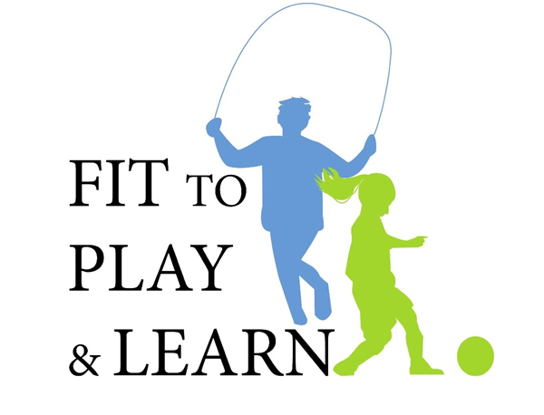

Feedback Survey

In an effort to continue to improve upon our program experiences, as well as to better support you, please provide us with your honest feedback. These surveys will remain strictly confidential.

QUESTION | ALWAYS / STRONGLY AGREE | OFTEN /  AGREE | SOMETIMES / DISAGREE | NEVER / STRONGLY DISAGREE
1. I learned from the presentations. | 1 | 2 | 3 | 4
2. I will make changes based on the information I learned. | 1 | 2 | 3 | 4
3. I understand obesity better. | 1 | 2 | 3 | 4
4. The program was well organized. | 1 | 2 | 3 | 4

Based on what I learned today, I will make the following three changes at home:
1.
2.
3.

Are there any topics or issues that you think should be addressed in future talks?

What did you like most about the program?

What would you change about the program?

