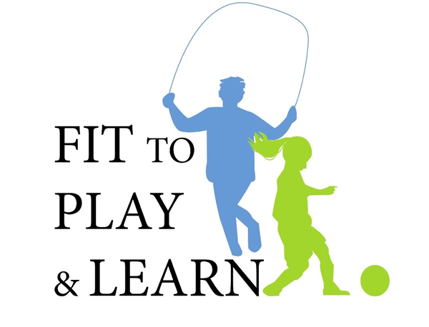

Feedback Survey for Presenters

In an effort to continue to improve upon our program experiences, please provide us with your honest feedback. These surveys will remain strictly confidential.

QUESTION | ALWAYS / STRONGLY AGREE | OFTEN /  AGREE | SOMETIMES / DISAGREE | NEVER / STRONGLY DISAGREE
1. The lesson plans enhanced the students’ learning. | 1 | 2 | 3 | 4
2. The demonstrations were helpful to support to program themes. | 1 | 2 | 3 | 4
3. I felt well-trained. | 1 | 2 | 3 | 4
4. I felt the program was well organized. | 1 | 2 | 3 | 4
5. I felt the program was effective for this age group (4-5th grade). | 1 | 2 | 3 | 4
Please you back of form if needed.
Are there any topics or issues that you think should have been addressed in the program?

Were there any obstacles in presenting this curriculum? Are there any changes that you would recommend?

Did your school use the in-class reinforcement material provided?

Approximately how many students took part in the program and what were their ages?
Name of School and Contact info:

Would you want to do this program again in the future? Yes or No
Please mail this feedback survey along with the Pre-tests, Post-tests and Student/Parent feedback surveys to the Fit to Play and Learn Team.

