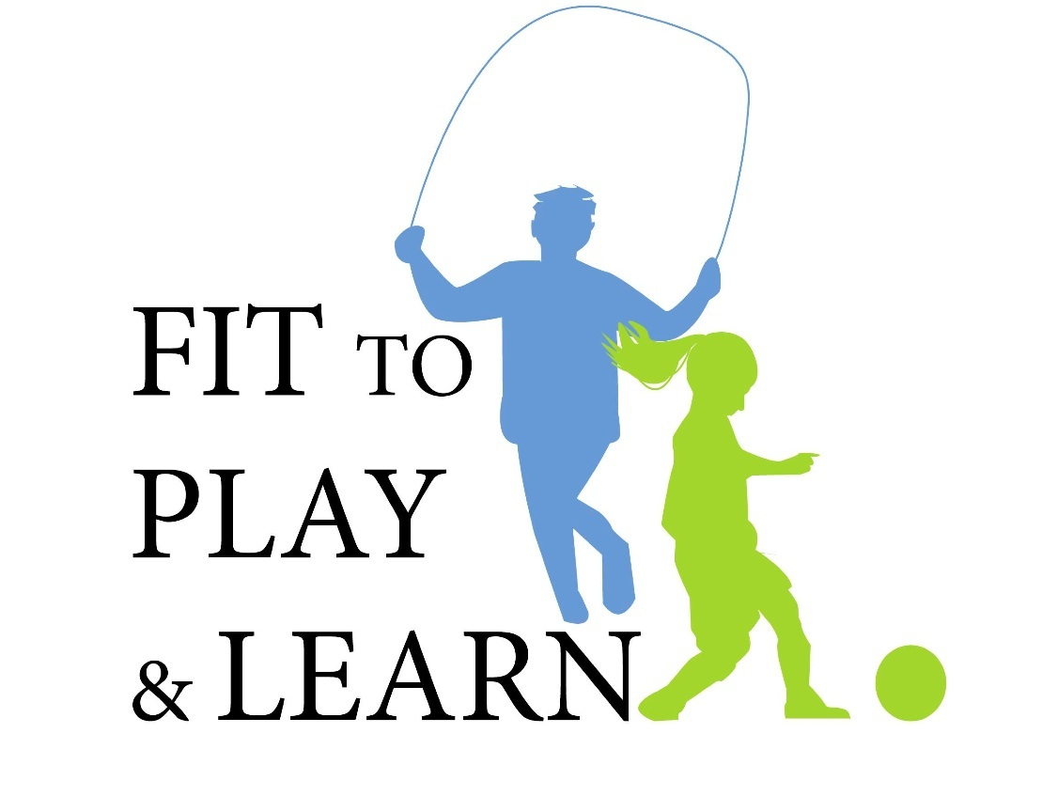

Eating the Colors of the Rainbow Lesson Plan: To Augment and Reinforce Session 3
Objective: To teach children about the importance of eating Colors of the Rainbow, an array of fruits and vegetables, every day. They will be able to identify a large variety of fruits and vegetables and practice incorporating them into their daily diet.
Motivation: Provide a chart of the human body. (If no diagram is available have children point to their own body parts, eyes etc.)
Nature provides so much of what strong minds and bodies require. Point to different parts (eyes, skin, brain, heart) and indicate which fruits and vegetables feed these parts. We want to grow powerful minds and bodies. Let’s see how much Rainbow Eating we can enjoy every day (at least 5 servings).
Procedure:
- How many different fruits and vegetables can we name of each color?
Have color boards or write the name of each color at the top of blackboard (Red, Orange, Yellow, Green, Blue, Purple, Brown, White). Have the students identify as many colored fruits and vegetables as they can and have a scribe list them under the appropriate color.

- On another board, or across the blackboard, have a large sample of their follow-up homework assignment from Session 2 “Rainbow Eating-Eating the Colors of the Rainbow.” The homework handout is a chart with the days of the week along the left side and the rainbow colors across the top (red, orange, yellow, green, purple, brown/black, white). For homework, students are asked to record the colors of the fruits and vegetables they eat for 1 week

- In class, ask students to share what colored fruits and vegetables they have already eaten earlier in the day. Record the class totals, on the in-class chart or blackboard as a demonstration so the students can understand what to do at home. Discuss the results.

Follow-Up Activities: These activities will reinforce the lesson’s objectives and support memory binding and daily practice of Rainbow Eating choices.
Rainbow Eating Chart Follow-Up
In class the next week, the students will return their Rainbow Eating Charts and share their results.
- Discussion: Was this easy or hard? Were there stumbling blocks to their goal of eating a variety of colors -- fruits and vegetables? Strategize together on possible remedies.
- To reinforce Math skills, have students create a bar graph with the colors and plot how many fruits and vegetables they ate of each color.
- With colors again written across the blackboard ask students to share their results. On the blackboard, tally up and determine which colors were the most to least popular. Discuss the results. Were there any colors that weren’t eaten at all? Can they think of fruits or vegetables in these groups that could be tried?

Further Math Enrichment – For those doing averages in school, have them calculate the average number of fruits and vegetables eaten per day. Students could also calculate the class’s average for the week.
Art Enrichment – Students can bring in clippings of fruits and vegetables from magazines, newspapers and grocery flyers.
- In groups or alone, students can make Eating the Rainbow posters or collages of their clippings, each can focus on one color, or they can each be a rainbow of choices. Posters can be placed around the room as a reminder of healthy foods.

Science Enrichment – Lessons on climate and seasons can be utilized to expand upon their understanding of the importance of Rainbow Eating. Discuss the different conditions provided by different seasons, allowing fruits and vegetables to grow at various times of the year; ie, rain, sun, temperatures. For example, the temperate climate of Southern California affords the plentiful produce of grapes, tomatoes, oranges, lemons, etc.
- Follow-up – Students can then apply these principles to one of their favorite fruits or vegetables and research where, when, and what conditions are needed for their growth.

