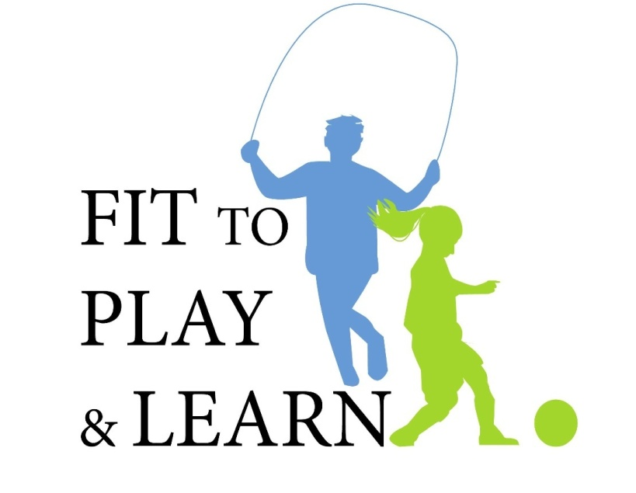
Instruction Manual for Session Presenters:

Prior to each session presentation, print out slides WITH NOTES. A note section accompanies the PowerPoint slides and will assist presenter with needed material to run session.

Student Session 1: Fit To Play and Learn
What you will need:
- Handouts:
- Pre-Test Handout- One for each student. Students will need pencils to fill out Pre-test.
- Treasure Map
- Guide to Health Insurance & Finding a Doctor
- 2 Backpacks, one filled with books
- Computer with PowerPoint presentation Student Session 1
- Notes from Student Session 1 PowerPoint presentation

Instructions:
- Have students fill out Pre-Test prior to beginning session. Collect Pre-Test prior to beginning session. Hold on to Pre-Tests until end of program series and return them to FTPL Program Coordinator.

- There will be one physical activity break during this session
Have kids do one of the following:
- Walk in place for a minute
- Jumping Jacks for a minute
- A combination of walking & jumping jacks
- Any other physical activity of your choosing for one minute

- There will be 1 interactive activity in this session the Backpack Demonstration
What you will need:
- One backpack filled with books
- Two volunteers from the audience
- Have the two volunteers do jumping jacks for 20 seconds, one wearing the heavy backpack, one not wearing a backpack. (Alternative activities to jumping jacks: Walking/Running across the room)
- Then have the students switch and do jumping jacks for another 20 seconds.
- Emphasize how much harder it is to do these activities with the extra weight of the heavy backpack.
- Have the volunteers describe how it felt, if they thought it was harder than usual, and if they felt any pains and strains on their bodies.

Homework: Students will be instructed at end of Session 1 to bring in nutrition labels from food packages from home for use during Session 2.

Student Session 2: You Are What You Eat
What you will need:
- Students will need Nutritional Lables from food packages that they were asked to bring in at the end of Session 1.
- Handouts: One for each student
- Food Labels Handout
- Food Labels 2 Handout
- Build a Healthy Meal Handout
- Food Log – to be given out as Homework at end of session
- Computer with PowerPoint presentation Student Session 2
- Notes from Student Session 2 PowerPoint presentation

Instructions:
There will be 1 interactive activity in this session. The students can work alone or in groups.
- Food Label Analysis – the slide show will prompt the speaker to distribute the two Food Label Handouts and the students will use the handouts to evaluate the labels they brought in from home to determine if the food is healthy or not.

Homework: Pass out Food Log. Instruct students to keep a food log for one week and bring to next session.

Session 2 In-Class Reinforcement Activities (optional):
The Fit to Play and Learn Guide and CD provide additional activities to be done in class by the students’ teachers to reinforce the material learned in this session.

Student Session 3: Healthy Food for a Healthy Life
What you will need:
- Handouts: One for each student
- My Food Plate Handout
- Build a Healthy Meal Handout – reviewed from last session
- 100 Calorie Snack – Handout
- Food Substitution - Handout
- Eating The Colors of The Rainbow – to be given out as Homework

- If doing the Food Presentation you will need those ingredients as well.
- Computer with PowerPoint presentation Student Session 3
- Notes from Student Session 3 PowerPoint presentation

Instructions:
There will be 1 interactive activity in this session. The students can work alone or in groups.
- Build a Healthy Meal/My Food Plate – the slide show will prompt the speaker to distribute the Build a Healthy Meal & My Food Plate Handouts and the students will be asked to brainstorm foods that fit into each group. They should be encouraged to think of foods that also meet the healthy meal requirements.

Homework: Pass out the Eating Colors of the Rainbow Handouts.
Instruct students to record what fruits and vegetables they eat on the Eating Colors of the Rainbow chart. This chart can be used in class with the optional Session 3 reinforcement activities provided in the Fit to Play and Learn Guide and on the CD.

Session 3 In-Class Reinforcement Activities (optional):
The Fit to Play and Learn Guide and CD provide additional activities to be done in class by the students’ teachers to reinforce the material learned in this session.

Food Presentation for Session 3 (optional):
The Session 3 slide show has a prompt for a Healthy Snack Food Presentation. If you are choosing to present this, a sample recipe follows:

Fruit & Veggie Kabobs

Ingredients:
- Kabob sticks
- 1 box of wax paper
- strawberries cut up
- green bell peppers
- red bell peppers
- bananas cut up
- low fat string cheese sticks cut into pieces
- cantaloupe melon balls
- apple cut into chunks
- cucumber slices
Cost per student: $.94

Student Session 4: Sugar Savvy: What’s in your drink?
What you will need:
- Handouts: Water Tracker to be given out as Homework
- Sugar Savvy Demostration Materials:
  - Box of Sugar
  - Teaspoon
  - 3 Clear Cups
  - 3 Index cards each labeled with one of the following:
- Coke (10 tsp)
- Gatorade (9 tsp)
- Capri Sun (4 tsp)
- Computer with PowerPoint presentation Student Session 4
- Notes from Student Session 4 PowerPoint presentation

Instructions: The slideshow will prompt the speaker to preform The Sugar Savvy Demonstration with the help of 3 student volunteers. This demonstration will reinforce visually how much sugar is in each of the beverages. It is crucial to use clear cups or glasses for the demonstraion as students must see the amount of sugar in the glass.
The Sugar Savvy Demonstration
Ask for three student volunteers.
Have the three student volunteers choose one of the 3 index cards. Have each measure out the teaspoons of sugar in their beverage and fill a cup with the appropriate amount of sugar. Place the index card in front of the cup of sugar in order to illustrate the sugar content of each of the beverages.

Homework:
Pass out the Water Tracker Handout and instruct students to keep track of how much water they drink in a week. Reinforce that water is the beverage of choice.

Student Session 5: Let’s Get Moving!
What you will need:
- Instant Recess DVD
- Handouts – Students and Parents will need a pen or pencil
- Pledge Sheet – to be given out at end of session
- Activity Log – to be given out at end of session
- Post-Test: one for each student
- Feedback Survey: one for each student
- Computer with PowerPoint presentation Student Session 5
- Notes from Student Session 5 PowerPoint presentation

Instructions:
1. There will be one Physical Activity Break during this session. Presenter will be prompted to take a 5-minute exercise break. This can be an Instant Recess DVD or any exercise routine of the presenters choosing.

2. At the end of the slideshow, the speaker will be prompted to pass out the Pledge sheets. These should be filled out during the session and signed by the students. Students should be instructed to bring the Pledge Sheet home and review and sign it with their parents.

3. Students should be given both a Post-Test and Feedback Survey at the end of the presentation. These should then be collected and returned along with the Pre-Tests taken during Session 1 and the Presenter Feedback Survey. All of these materials should be returned to the FTPL Program Coordinator at the end of the year.

Session 5 In-Class Reinforcement Activities (optional):
The Fit to Play and Learn Guide and CD provide additional activities to be done in class by the students’ teachers to reinforce the material learned in this session.

Parent Session:
This session will be presented by a representative of the AAP-Chapter 2. Please contact our Program Coordinator at fittoplayandlearn@gmail.com, once a date and time has been selected to ensure that one of our physicians is available.
The Host school will be responsible for publicizing the session to the parents so that the best possible turnout is achieved a flyer & letter explaining the program to the parents is included at the beginning of the manual and on the FTPL CD.

What the Host School will need to provide:
A Translator
A Computer for the PowerPoint presentation
Handouts: One for every parent (available in Spanish on the Fit To Play & Learn CD except where noted)
- Pre-Test
- The Parent Fit to Play and Learn Guide
  - Parent Guide Title Page
  - Food Labels Handout
  - Food Labels 2 Handout
  - My Food Plate Handout
  - Build a Healthy Meal Handout
  - 100 Calorie Snack Handout
  - Food Substitutions Handout
  - Pre-Test for Parents
  - Treasure Map
  - Guide to Health Insurance & Finding a Doctor
  - Picky Eater Handout (English only)
  - Budget Handout (English only)

Conclusion of the Fit to Play and Learn Curriculum:
At the completion of the series, please complete the Presenter Feedback Survey. Please bring the materials listed below to the end-of-year FTPL meeting. If you are unable to attend the meeting, please mail the materials back to the FTPL Program Coordinator at the address below so that we can continue to improve the curriculum and track our progress:
- Presenter Feedback Survey
- Student and Parent Pre-Tests
- Student Post-Test
- Student and Parent Feedback Surveys

Thank you for you participation in this program. If you need any assistance with the materials please contact The Fit to Play and Learn Team creators, Dr. Corinn Cross and Dr. Tracy Zaslow at fittoplayandlearn@gmail.com.

Correspondence can be sent to:
AAP Chapter 2
Box 527
4067 Hardwick Street
Lakewood, CA 90712

