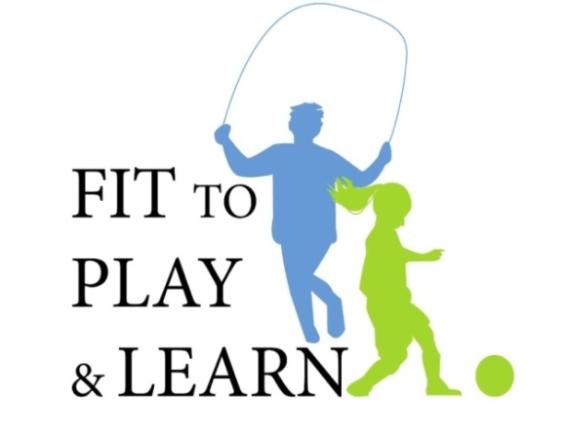
Welcome to the Fit to Play & Learn Program!
Fit to Play and Learn is a program created by doctors. The program teaches students and their families how to live healthier and more active lives.
One in 3 children are overweight. When a child is overweight it can harm their health. Being overweight can lead to heart disease and diabetes. Unfortunately, Los Angeles has one of the highest rates of childhood obesity. Your child’s school is working with doctors at the Fit to Play and Learn Program to try to stop this growing problem.
Your child’s class will be participating in the Fit to Play & Learn program throughout the school year. The program will be taught by the school nurse. Your child’s teacher may assign other activities to be done at home. Doctors and fitness experts from your community will also give talks.
The Fit to Play & Learn program will teach your child about healthy eating, smart drink choices and fun ways to be active. We hope the whole family will make healthy changes together. Your support to try these healthy lifestyle changes your child is learning about in class.
Fit to Play and Learn is for parents too! Parents are invited to a special parent session where a doctor will come and talk to you at your child’s school. We will discuss what your child is learning. This talk will give parents tips on how to prepare healthier meals and how to get your children to eat them. The doctor will also answer your questions about the program and how obesity may be affecting your child.
Living a healthy life is easier with the help of your doctor. If you don’t already have a doctor for your children, the Fit to Play & Learn Program will give you information about how to find a doctor and enroll in health insurance.
Together we can make a difference. Let’s get ready to eat healthier and get moving!
All the best,
The Fit to Play & Learn Team
Drs. Cori Cross and Tracy Zaslow
Fittoplayandlearn@gmail.com
The Fit to Play and Learn program is sponsored by the American Academy of Pediatric - California Chapter 2

